# **image1.pngDepartment of Computer Science and Engineering Islamic University of Technology (IUT)** A subsidiary organ of OIC

# **Lab Report 1**

# CSE 4512: Computer Networks Lab

## 

## **Name: Rashikh Ahmad Student ID: 210041255 Section: 2(A) Semester: 5th Academic Year: 2023-24**

**Date of Submission: 16/09/24**

### **Title:** Familiarizing with the Packet Tracer environment

### **Objectives**:

1. Download and install Cisco Packet Tracer
2. Learn about use-cases of Cisco Packet Tracer
3. Get acquainted with different components of Cisco Packet Tracer environment
4. Understand how to operate Cisco Packet Tracer

**Note**: For writing the report, you can take help from online resources. But you should not just copy and paste. Write in your own words. Also don't copy from any other student. When taking help from online resources, please provide appropriate references at the end of report.

**Introduction:**

Cisco Packet Tracer is basically a renowned simulation software offered by Cisco systems. It is used to create complicated network topologies, as well as to test and simulate abstract networking concepts.  The interface is easy to use where the user can drag and drop elements to create their network environment. Some use-cases are mentioned below:

* + 1. CPT basically helps students figure out different problems of various networking principles in order to prepare for an exam.
    2. Students can apply their book learning to a new environment. They can design networks with topology elements such as routers, switches, cable connectivity etc.
    3. The professional individuals can use Cisco Packet Tracer as a means to test network changes before applying them to the actual network.

### **Interface of Cisco Packet Tracer:**

(Explain the options/elements available in each of the interface listed below with necessary screenshots. For example, you can explain what a switch is with a sample switch from device-specific selection box, what are the options available inside a switch etc.)

P.S. *Do Not Copy Paste From Others*

* **Menu Bar:**



The available options are:

**File**, **Edit**, **Options**, **View**, **Tools**, **Extensions**, **Window** and **Help**.

* **File** allows us to do basic operations like open a new file, save the file, save the file as PKZ etc.
* **Edit** option allows us to copy, paste, undo and redo actions.
* In **Options** there are preference settings, algorithm settings, profile settings.
* **View** option allows us to customize the environment as we like for example removing certain toolbars, zooming in and out etc.
* We can see the drawing palette in the **Tools** section. We can also customize the dialog box.
* We will be able to access the activity wizard from the **Extensions** section. Also there are other options like multiuser, IPC, scripting etc.
* **Window** allows us to access full screen.
* And finally, **Help** allows us access to tutorials and contents.
* **Main Tool Bar:**



The main toolbar has shortcuts to the options that are provided in the menu bar such as: File, Edit, Undo, Redo, Zoom in and out, the drawing palette etc. There is a network Info button too.

* **Logical/Physical Workspace and Navigation Bar:**

**Picture 8**

**It’s there to toggle between Logical and Physical workspace.**

The Logical Workspace bar enables us to return to a previous level within a cluster, generate a new cluster, relocate objects, adjust the background, and observe the surroundings.   
  
The Physical Workspace toolbar enables us to move through physical places, return, establish a new city, construct a new building, set up a new general container, form a new closet, build a new rack, set up a new table, create a new inventory shelf, and establish a new cable pegboard.

* **Realtime/Simulation Bar:**

**Picture 9**

This bar helps to toggle between Realtime and Simulation Mode. There’s a timer that shows the since CPT is launched. ‘Power Cycle Devices’ and ‘Fast Forward Time’ these to buttons are there next to the timer. And in the Simulation Mode, we have the Play Control Buttons and the Event List toggle buttons.

* **Network Component Box:**

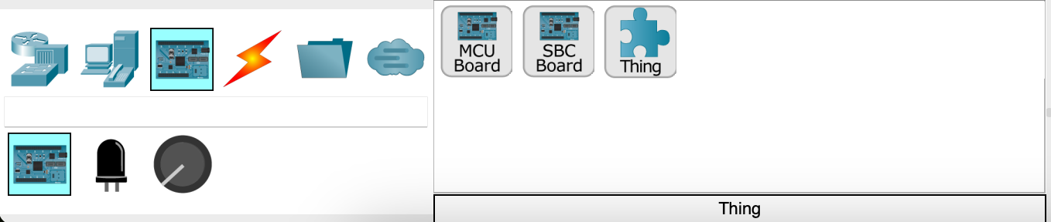

This area shows us the Device-Type Selection Box and the Device-Specific Selection Box. We can choose the type of device and specify the device that we want to work with and drag it onto the workspace for further work.

* **Device-type Selection Box:**

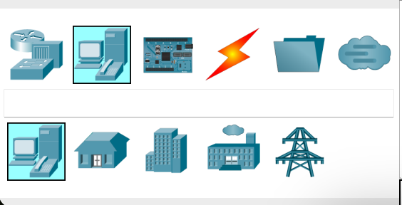

This area here helps us to select the type of device required for us. The available devices are: Network Devices (Subtypes: routers, switches, hubs, wireless devices, security, WAN emulation), End Devices (Subtypes: end devices, home, smart city, industrial, power grid), Components (Subtypes: boards, actuators, sensors), Connections (Subtypes: connections, structures cabling), Misc, Multiuser Connections.

* **Device-specific Selection Box:**



This area allows us to select a specific device from the available types that we have seen in the Device-Type Selection Box. Under this section different types of routers like 4331, 4321, 1941 etc., end devices like laptop, pc, server etc. so on and so forth. There is a wide variety of devices that are available to us in this area. We can choose these devices from here and put them in the workspace to build our network.

* **User Created Packet Window:**

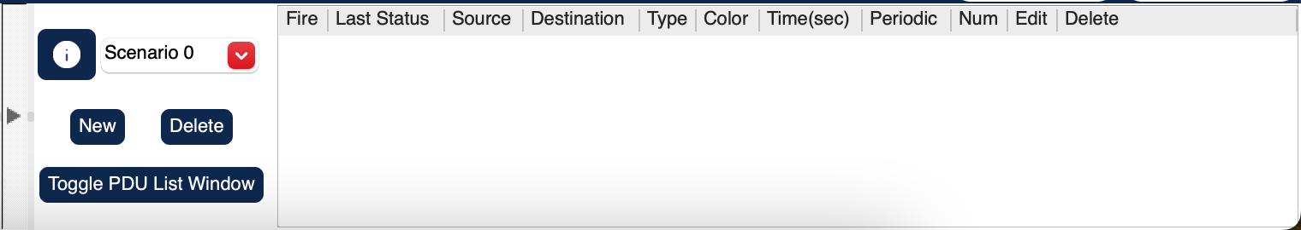

This is to manage the packets that we have put in during simulation scenarios.

### **Key Features of Cisco Packet Tracer:**

* We’re able to customize single or multi-user activities
* Cross-platform compatibility
* Visualizing Networks
* Real-time and simulation mode
* Compatible on various platforms
* Support to all languages
* Most networking protocols are supported
* Environment is interactive
* Can be used on unlimited devices

**Challenges faced and Solutions:**

* + The first mental challenge I faced was whether CPT has a MacOS version or not. Glad for the cross-platform availability.
  + The second challenge actually hit me when I actually opened the software and saw the interface. It seemed very complicated and unknown at first sight. But I got used to the layout as I dived into completing this assignment and get to know the details of the tools present in the layout.

**References:**

* <https://www.networkstraining.com/cisco-packet-tracer-guide-for-beginners/> (A guide for beginners)
* [https://www.pynetlabs.com/cisco-packet-tracer/#Features_of_Cisco_Packet_Tracer](https://www.pynetlabs.com/cisco-packet-tracer/%23Features_of_Cisco_Packet_Tracer) (CPT and its features)
* <https://www.geeksforgeeks.org/what-is-cisco-packet-tracer/>

**PART 01**

**Step 01:**

The only visible event that is HTTP.

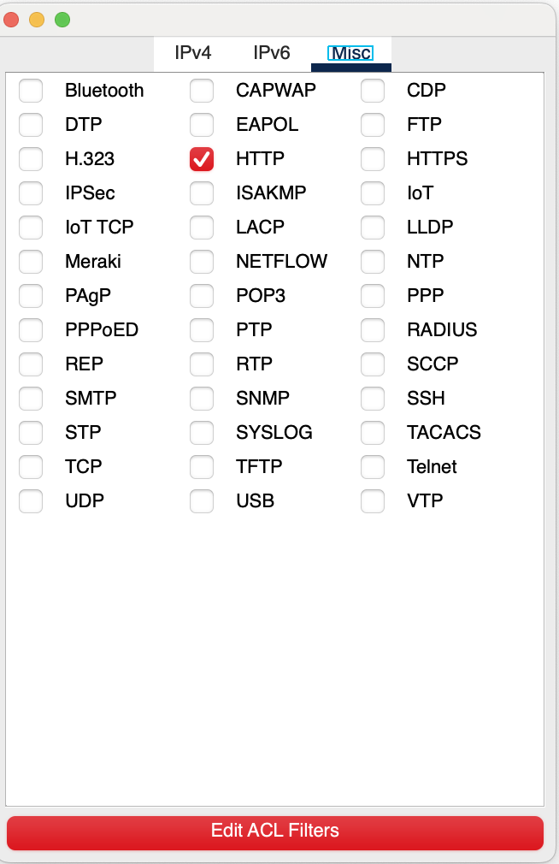

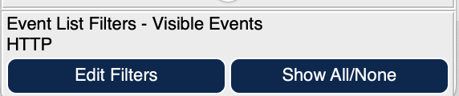

**Step 02:**

**Web client > Desktop tab**

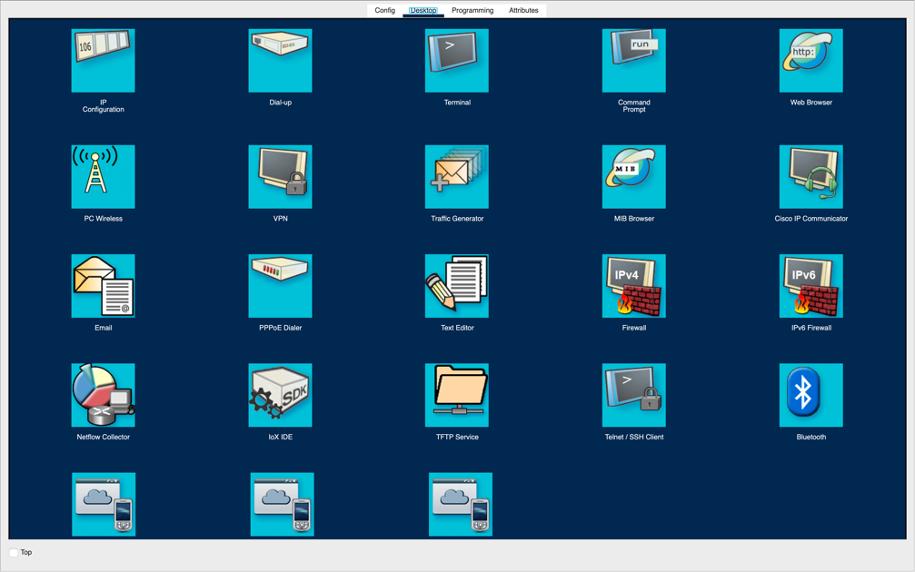

**Web client > Desktop tab > Web Browser**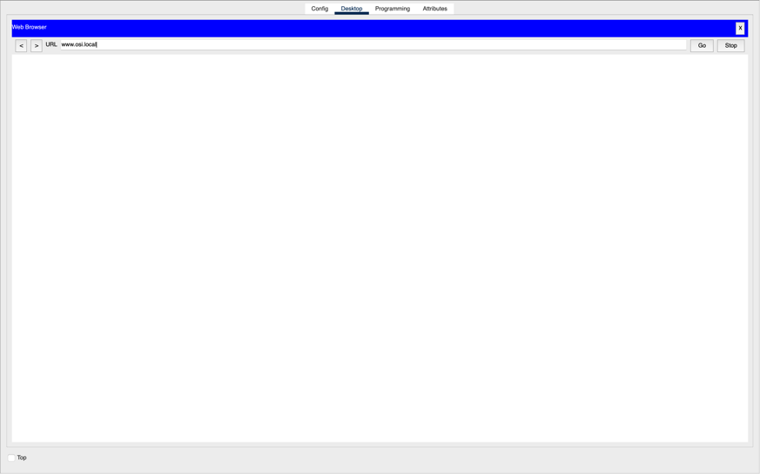

**In the URL field, put www.osi.local and click Go.** 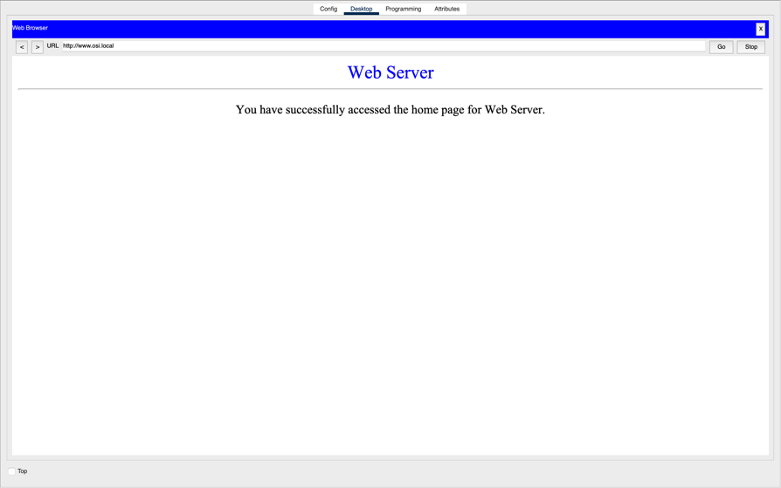

**Clicking capture/forward four times which generates four event lists.**

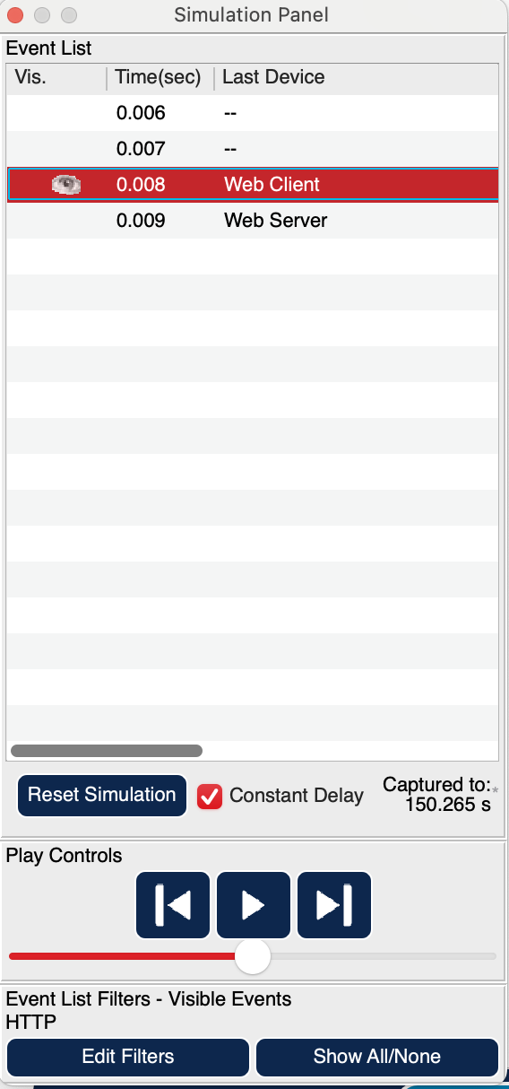

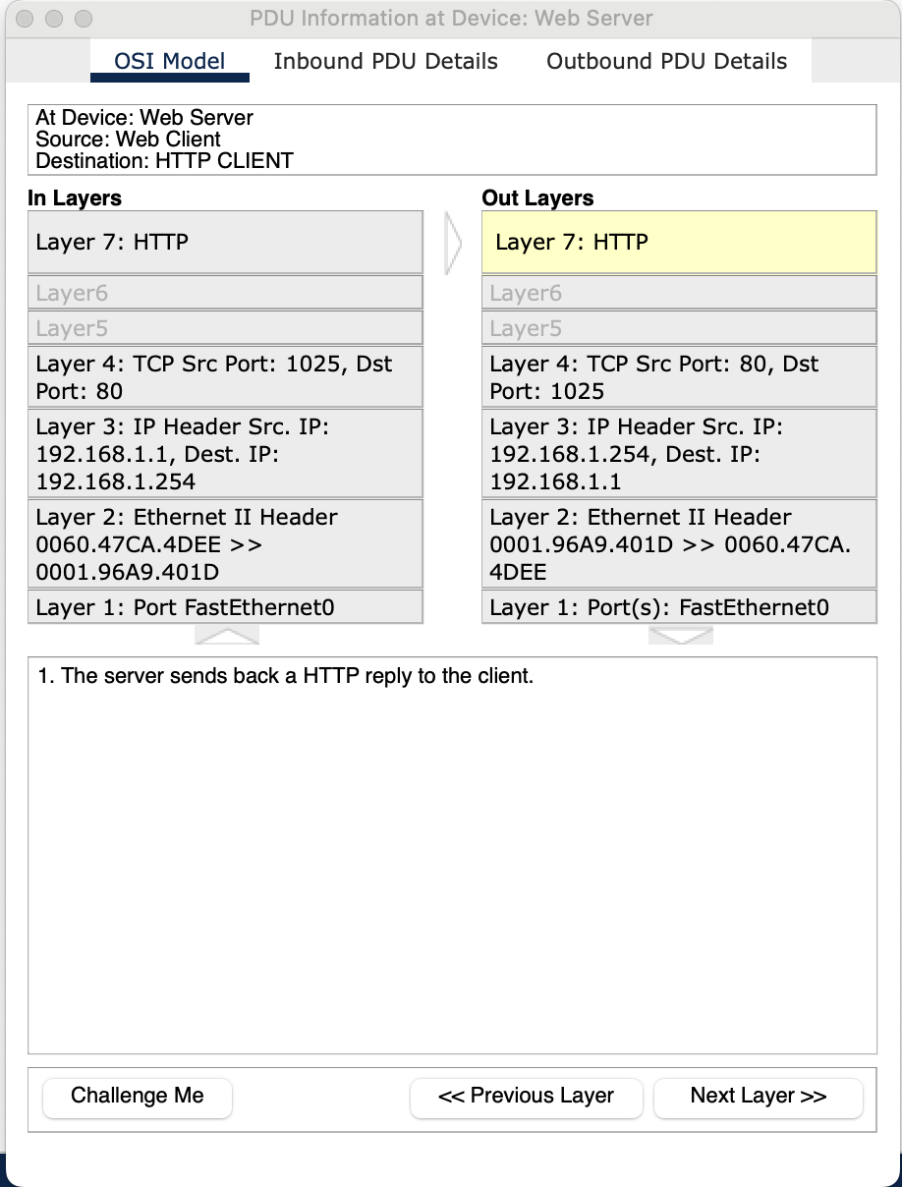

**(b) The text displayed next to Layer 7 is HTTP.**

The information of the 7 layers is present directly below the In Layers and Out Layers boxes.

**(c)** The Dst Port value in layer 4: 1025.

**(d)** The Dest. IP value in layer 3: 192.168.1.1

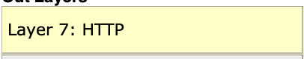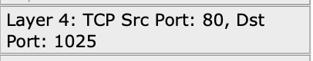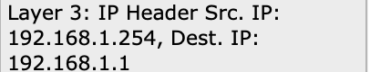

**(e)**

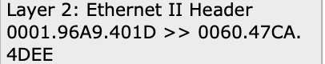

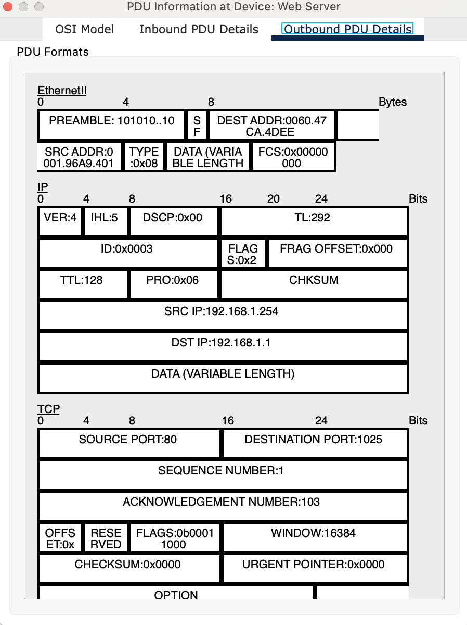

**(f)** The IP section of the PDU Details is associated with the layer 3 as the DST IP matches.

The TCP section of the PDU Details is associated with the layer 4 as the DST PORT matches.

**(g)**

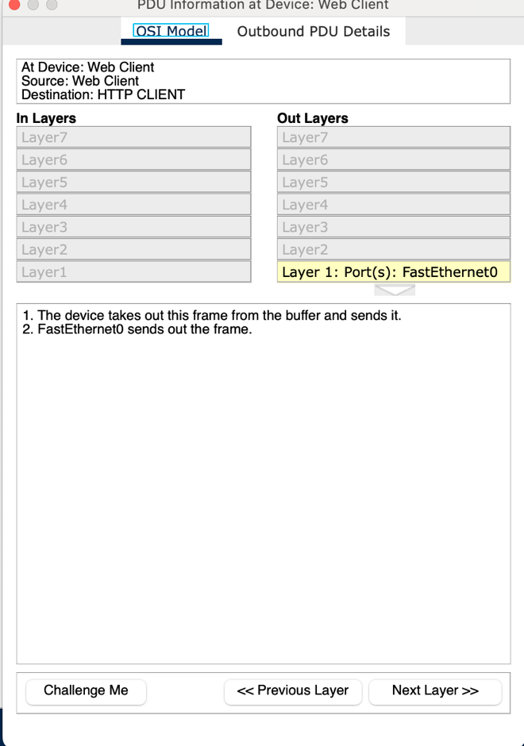

**(h)**

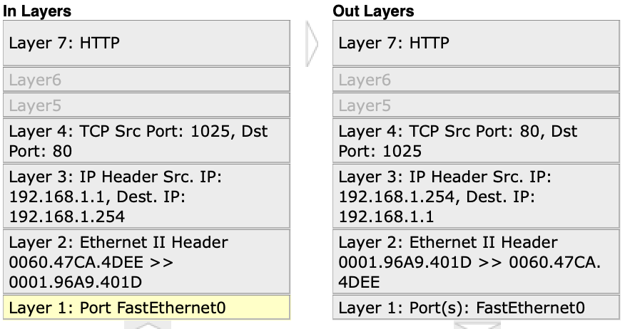

The major differences here are the Dest port and IP address.

**(i)**

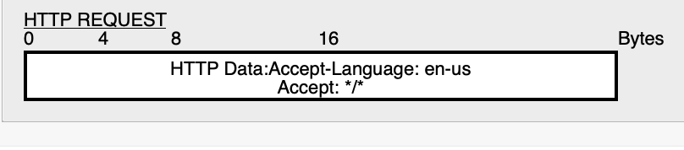

**(j)**

**Picture 31**

**PART 02**

**Step 01:**

**(b)**

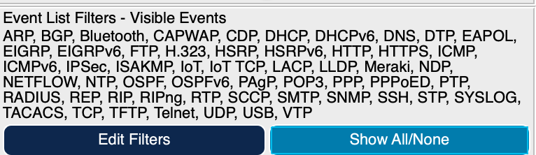

**(c)**

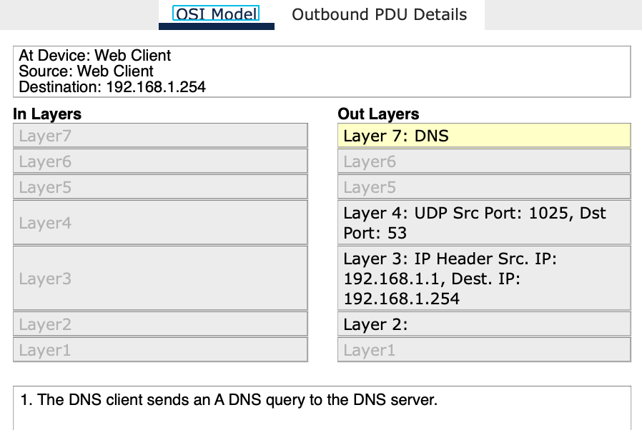

**(d)**



**(e)**

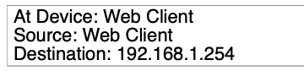

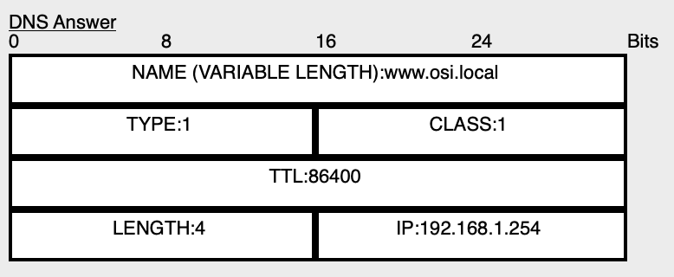

**(f)**

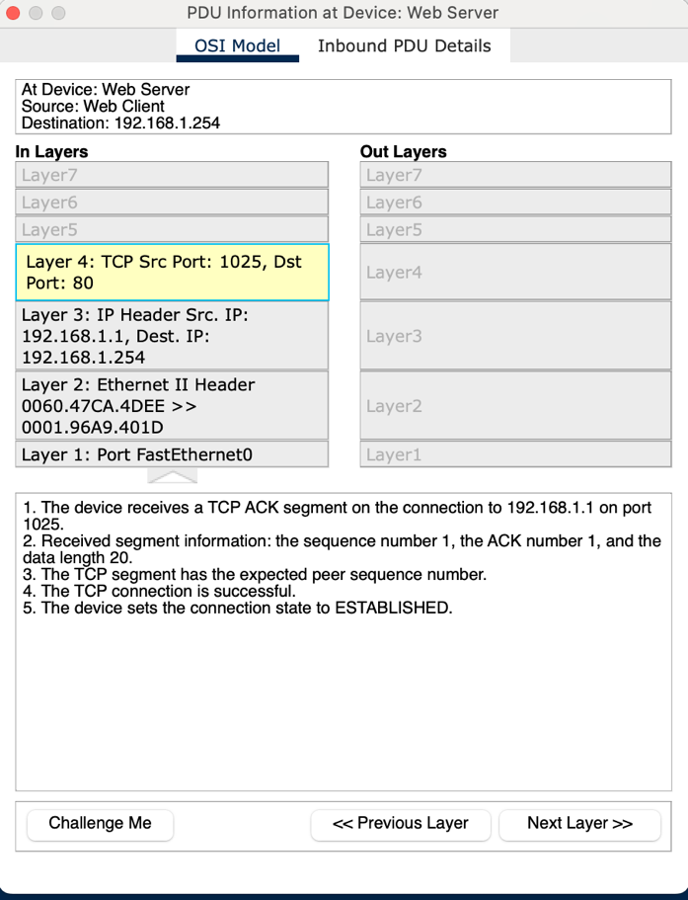

**(g)**

